CHEMICAL ENGINEERING TRANSACTIONS  VOL. , 2023 | A publication of
The Italian Association
of Chemical Engineering
Online at www.cetjournal.it

Guest Editors: David Bogle, Flavio Manenti, Piero Salatino
Copyright © 2023, AIDIC Servizi S.r.l.
ISBN 979-12-81206-04-5; ISSN 2283-9216

Separating Hydrogen from Syngas (produced from the Gasification of Waste) using Pressure Swing Adsorption – Methodology and Results
Stan T. Kolaczkowski^{a,*}, Paul Willacy^{b}, Myron D. J. Jones^{b}, Marshall Pugh^{b}
ªDepartment of Chemical Engineering, University of Bath, Claverton Down, Bath, BA2 7AY, UK
^{b}Compact Syngas Solutions Ltd, Whittle Close, Engineer Park, Sandycroft, Clwyd, CH5 2QE, UK
*cesstk@bath.ac.uk
There is much interest in the production of energy from waste via gasification to produce a Syngas/Producer gas stream, containing CO, H₂, CO₂, CH₄, H₂O, and N₂. From such a stream, H₂ could be separated creating a clean fuel to act as an energy vector. The generation of Syngas from natural gas via Steam Methane Reforming and the application of pressure swing adsorption (PSA) to separate hydrogen from such gas is well known. Unfortunately, it was difficult to find a supplier of PSA equipment, who would on reasonable terms: (a) engage with R&D trials at a much smaller scale; (b) design for lower operating pressures; and (c) perform trials with real Syngas from waste, which will contain contaminants. Therefore, an in-house designed PSA was developed as described in this study. Since, in the waste-to-energy industry, a very high purity ‘fuel-cell’ grade of H₂ is not essential, as well as for many ‘fuel-switch’ applications, an H₂ purity of ~95 vol% is considered acceptable. Trials were initially performed in a long Single-Bed PSA (52 mm diameter; 8 m long). Starting with a synthetic syngas mixture, it was confirmed that H₂ purity >90 vol% could easily be achieved. Then the design was scaled up to a shorter but larger diameter Twin-Bed PSA system (bed diameter: 888 mm; length1.5 m), in which an H₂ purity >95 vol% was achieved using a real Syngas from a waste-to-energy gasifier (design output: 500 Nm3/h of Syngas).
  - Introduction
The UK Government is committed to reducing carbon dioxide emissions, and the transition to the use of hydrogen as a fuel is seen as one of the many steps which could be taken. However, to be carbon neutral, hydrogen not only has to be produced in a way for which CO₂ is either not created, or if it is, then it is sequestrated. Also, the infrastructure needs to be in place to supply the H₂ in a form and level of purity that can be utilized by an end user. Different labels have been assigned to hydrogen (grey, blue, and green) depending on how it is produced. It is well known (e.g., Rostrup-Nielsen and Christiansen, 2011) that H₂ on an industrial scale, is produced via Steam Methane Reforming (SMR), using hydrocarbon-based feedstocks, such as natural gas. Such hydrogen, which is produced from fossil-based fuels, without any CO₂ capture/sequestration is currently described as ‘grey’ hydrogen. At the other end of the scale, hydrogen produced by electricity generated by renewable energy is described as ‘green’ hydrogen, because fossil-based fuels are not used, and CO₂ is not produced in that process.

In the UK, the motivation to produce energy from waste arises from the need to reduce the amount of waste sent to landfills. There, the carbon constituent in the waste would degrade over time and produce CO₂ and CH₄ emissions. By segregating the waste at a waste reception center, it can be turned into a product that has a high calorific value and could be used as fuel. Such material is known as a Refuse Derived Fuel (RDF), which can act as a feedstock to a gasification process, producing a gas stream containing CO, H₂, CO₂, CH₄, H₂O, and N₂. Such a gas stream is often called a Syngas/Producer Gas, depending on the terminology used in a particular industry/company - in this paper, the term Syngas will be used. Descriptions of gasifiers and the chemistry of the process are available in the literature (e.g. Higman and van der Burgt, 2003; Knoef, 2005), and in this paper, the techniques are applied to a Syngas produced from a down-draft gasifier operating at a negative pressure using RDF and air as a feed streams. From the Syngas the H₂ could be separated creating a clean fuel to act as an energy vector – an outline process scheme is illustrated in Figure 1.
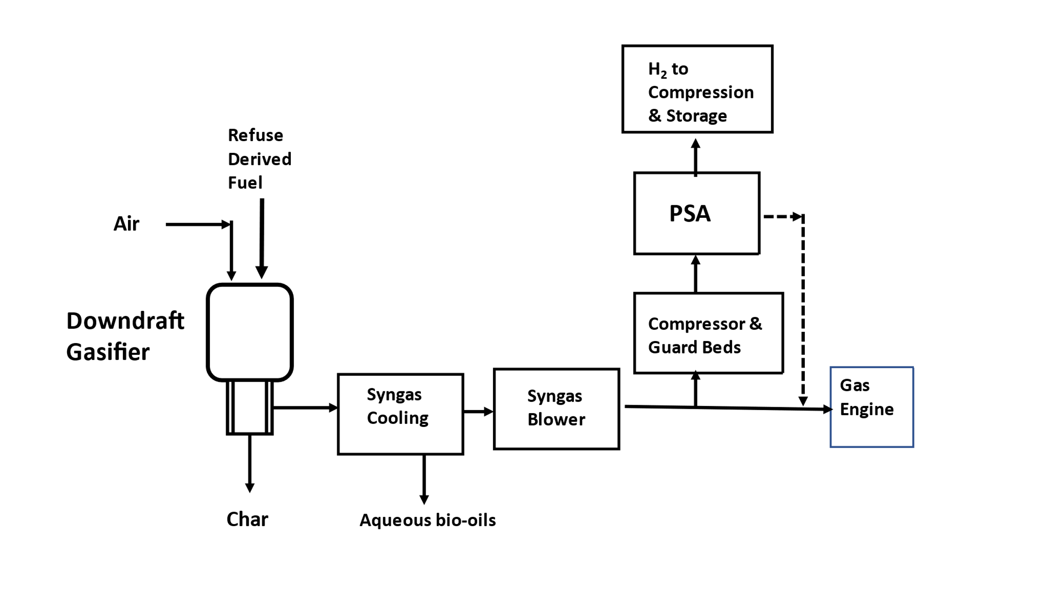
Figure 1: Simplified schematic to illustrate the key unit operations and application of PSA to produce H₂.

In the petrochemical sector, Syngas is already produced on a large scale, using the well-established SMR technology and the PSA process is often used to produce high purity H₂ from that Syngas. That PSA technology is applied to a process which is at a very much larger operational scale than applications considered in the waste sector. As it was difficult to find a supplier of PSA equipment, who would on reasonable terms: (a) engage with Research & Development trials at a much smaller scale; (b) design for lower operating pressures; and (c) perform trials with real Syngas (from waste) - it was decided to develop an in-house design of PSA to separate H₂ from Syngas. The PSA process consists of rapid pressure swings, over a prescribed cycle, with changes taking place at time intervals of ‘seconds to minutes’ – and this is adequately described in many papers and textbooks (e.g., Crittenden and Thomas, 1998). However, there is little information on design methodology, an aspect that is considered proprietary.
A useful starting point on how the PSA works is the description in the pioneering patent by Skarstrom (1960), in which the application of a pressure swing process to separate components in gaseous mixtures is described. From that, it is clear that in the PSA cycle a bed back-purge step needs to be employed in order to increase the purity level of the product stream. There was also much information gathered from publications (e.g., Ackley, 2019) on the use of PSA to concentrate O₂ from the air, which was helpful to understand the more generic aspects of PSA design - then on hydrogen separation information was gathered from publications on that topic (e.g., AIGA, 2018) and other literature from vendors of PSA equipment and their websites. To achieve very high purity levels schemes become complex, and as an example in Chou et al. (2013) a two-stage dual-bed eight-step PSA process is studied to produce high-purity H₂ and to capture CO₂ from synthesis gas.
  - Process design and methodology
In the industrial setting in which this project was based, there was a need to fast-track the understanding and develop in-house know-how in the PSA field resulting in several challenges. After studying the literature, and performing some short-cut design calculations, it was decided to gain direct experience of the PSA process. This started with trials in a relatively small diameter (52 mm) column (Phase 1), and then that knowledge was used to scale up the design (Phase 2) to a larger diameter (888 mm) bed. This paper describes the progress made in a commercial setting and emphasis is placed on the followed methodology and design strategy developed. However, specific information on the adsorbents which were used is not disclosed, as that is considered proprietary knowledge. Anyway, in illustrating the methodology, some of the results are still presented to illustrate the type of information obtained and the decisions that followed.
    - Phase 1 trials in the single small-diameter PSA bed
An outline schematic of the equipment used is presented in Figure 2. In these initial trials a synthetic gas mixture was used to represent the Syngas feed and the back-purge product gas stream. The composition of these synthetic streams is presented in Table 1 together with a base-case product output stream from the gasifier. The base-case reflects a condition in which the gasifier operates with an air feed, and the H₂ concentration in the dry Syngas varies from 12 to 14 vol%. The O₂ in the air fed into the gasifier is consumed in the combustion and partial oxidation reaction which provide the heat in the gasifier to support the complex combination of reaction (series & parallel), which leads to the production of Syngas. If an O₂-enriched air stream is fed into the gasifier, then a higher H₂ concentration in the Syngas can be achieved. However, for the work described here, the base-case situation was used. The diameter of the bed was 52 mm, and its overall length was long (4 + 4 = 8 m), to magnify the effects to be observed.
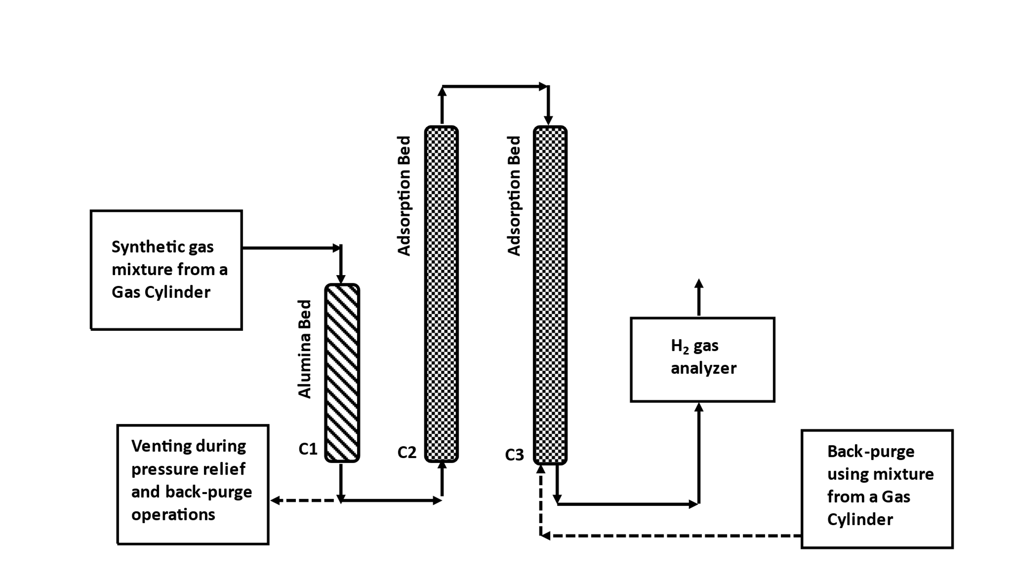
Figure 2: Schematic to illustrate the configuration used in Phase 1, representing a long PSA bed. The bed in C1 was used to trap moisture (length 2 m). The adsorbent was in C2 & C3 with a total bed length = 4 + 4 = 8 m. The alumina bed C1 was maintained at a fixed pressure and the PSA cycle was only performed on C2 & C3.

Table 1: Composition of real and synthetic Syngas and back-purge streams
Species | Real  Syngas  vol% | Synthetic Syngas S1  vol% | Purge  Gas S2  vol% | Purge  Gas S3  vol%
CO  CO₂  CH₄  H₂  O₂ | 18-19  12  2.6  12-14  0.15 | 19  12  3  14  0 | 2  1  1  61  0 | 4  2  0  90  0
N₂ | 51-52 | 52 | 35 | 4

In the studies planned, the concept for how the PSA scheme might be developed is illustrated in Figure 3a. Trials with the long PSA bed started with a feed of Synthetic Syngas S1. The results of a trial with and without a back-purge step using a synthetic purge S2, are shown in Figure 4a. Looking at the results, the presence of a back-purge makes a huge difference in H₂ purity obtained. The effect of an increase in the duration of the back-purge is illustrated in Figure 4b. Although duration of product output at a high purity is increased, it is at the expense of using H₂ in the back-purge. The gain in product from the use of H₂ in the back-purge needs to be balanced with product loss. From an operational perspective, the system can be designed such that a large portion of the H₂ in the purge gas stream can be retained in the bed and not lost, and then that H₂ features in the product from the PSA cycle that follows.
In the trials in Figure 5a, the operating pressure has been increased from 5 to 8 barg. Hence much higher H₂ purity is being achieved and even without a back-purge, greater than 60 vol% is being reached. This fulfils the design strategy illustrated in Figure 3a for the 1st Stage PSA. By not utilising a back-purge step, time is saved in the PSA cycle, and product is not used for the back-purge.

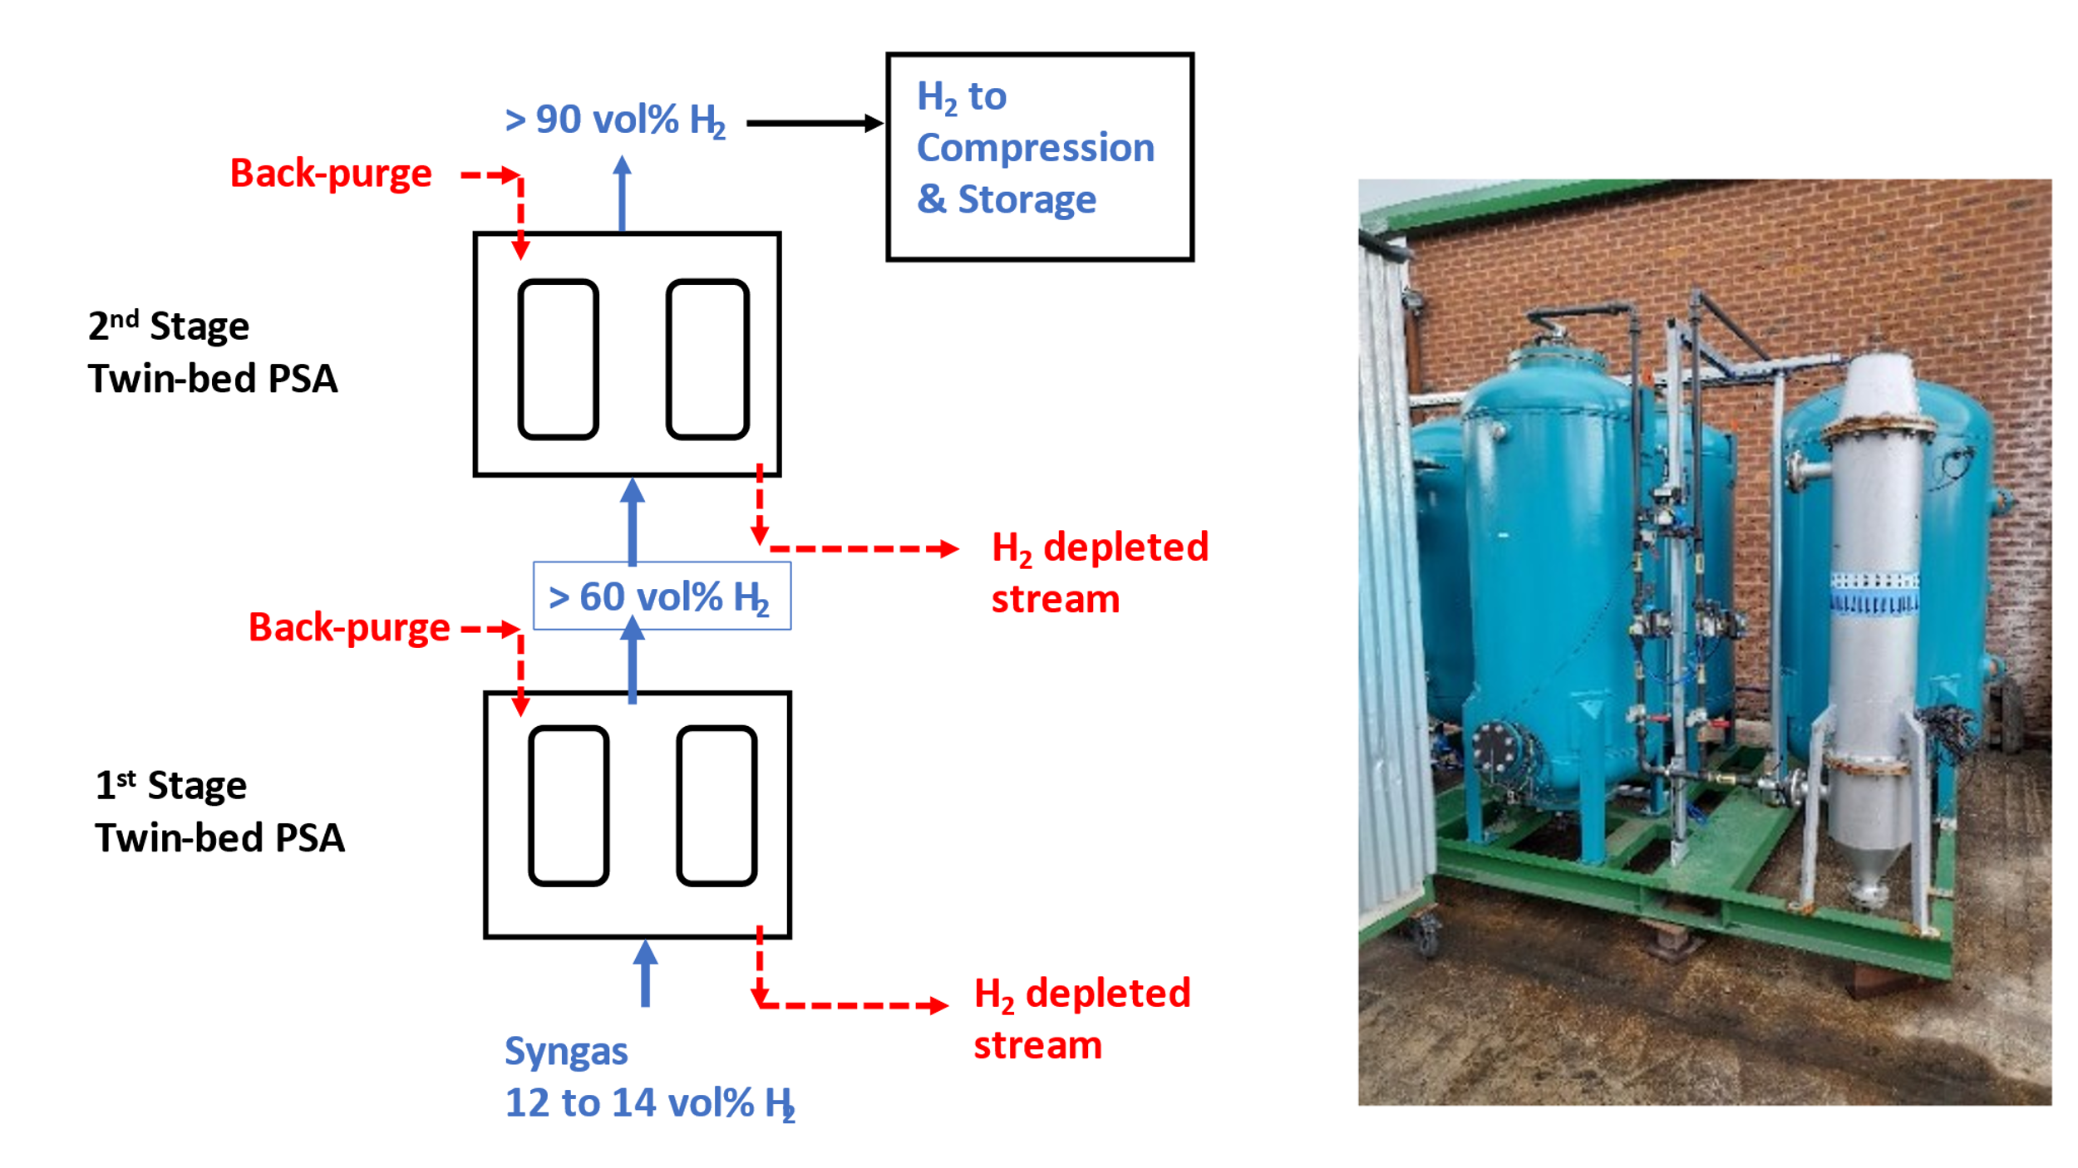
(a) (b)
Figure 3: Twin-bed PSA - (a) schematic illustrating the Two-stage Twin-bed PSA scheme which was being developed, and (b) photograph of one Twin-bed PSA (two blue-vessels in centre) used in the trials described in this paper (thinner grey vessel on right, is a syngas chiller, to cool the gas before the PSA beds).

Figure 4: Trials with S1 as feed, at ~5 barg using the long PSA bed, exploring the 1st Stage - (a) performance with and without back-purge (S2) and (b) performance as duration of back-purge with S2 is increased.

The long PSA bed was then used to consider how the 2nd Stage would work. The gas bottle mixture in S2 was used as a feed and the gas mixture in S3 was used in the back-purge cycle. The operating pressure was reduced to ~3 barg, to explore performance of the 2nd Stage at a lower operating pressure - hence save unnecessary syngas compression between the two stage (see Figure 3a). The results from such a trial are presented in Figure 5b and are very exciting as they demonstrate that a high H₂ purity (> 95 vol%) can be achieved.

Figure 5: Trials with a feed of S1, using the long PSA bed - (a) performance of the 1st Stage with a feed of S1, at a higher pressure ~8 barg (without and with back-purge with S2), and (b) performance of the 2nd Stage with a feed of S2, at ~3 barg (at different back-purge durations using gas mixture S3).

    - Phase 2 trials in the Twin-Bed PSA
Building on the knowledge gained in Phase 1, the cross-sectional area of the bed was scaled-up by a factor of x 290, leading to a Twin-bed PSA unit, with each bed having a diameter of 888 mm. The length of the adsorbent in the bed was reduced from 8 m down to 1.5 m. A photo of the skid-mounted PSA Unit is illustrated in Figure 3b. The unit consisted of: Syngas Receiver (2.2 m³); Syngas Chiller; 2 PSA beds; and H₂ Product Receiver (2.2 m³). The Syngas Chiller is installed to enable the temperature of the Syngas to be reduced before entry into the PSA beds. From the gasifier, a slip-stream of Syngas was diverted to the PSA part of the plant (see Figure 1), and a feedstock of RDF + Air was used to generate the Syngas.

Figure 6: Trials using real Syngas in a single-stage Twin-bed PSA, showing performance in the 3rd production cycle (total duration of cycle = 870 s) operating at ~1.5 barg - (a) H₂ product flow, and (b) H₂ purity.

One set of results is illustrated in Figure 6, showing the performance from individual beds (labelled PSA1 and PSA2). The product flow from PSA2 is higher that from PSA1, and the duration of high purity is longer from PSA2 than from PSA1. Despite the beds being packed in a similar manner, these types of differences occur in real trials, emphasizing the importance of such studies. This particular cycle consisted of the following key steps:
In PSA1: Bed pressurisation (4 → 426 s); H₂ product removal (204 → 426 s); Pressure relief (434 → 862 s);
Back-purge (738 → 860 s);
In PSA2: Pressure relief (2 → 430 s); Back-purge (306 → 428 s); Bed pressurisation (436 → 858 s); H₂
product removal (636 → 858 s).
A pressure equalisation step was not employed and back-purge was from the H₂ Product Receiver. In the Twin-bed PSA, each valve can be set to open or close at a set time independent of any other valve. The design permits a very wide range of flow options and timings to be considered. In many of the key lines, a manual flow control valve is positioned next to an actuated on-off valve – the setting on the manual valve can be adjusted. There were also turbine flow meters positioned in the H₂ product line and in the pressure relief line. Pressures were measured with transducers in the syngas storage receiver, PSA beds, and H₂ Product Receiver. Differential pressures were also measured across the adsorption beds. In PSA1, there were 15 RTDs located at 100 mm intervals in the axial direction, which protruded 50 mm into the bed – temperatures recorded provided useful information on the movement of the adsorption and desorption fronts.
  - Conclusions
The use of an 8 m long PSA bed, proved to be a very effective method of magnifying the performance of the bed during the adsorption phase in the PSA Cycle. This happens also in assessing the difference in performance of the bed (breakthrough) after back-purge, when changes were made to: (a) purge flow, (b) duration of purge, or (c) purge gas composition. The use of synthetic gas mixtures was an effective method of developing the experimental technique, and screening/assessing the performance of different adsorbents, without incurring unnecessary cost and distraction by having to operate the Gasifier to generate the Syngas.
In large commercial SMR processes, the syngas is produced at high pressure (e.g., 20 to 30 barg). Even in smaller scale SMR plants, operating pressures in the region of 10 barg are considered. However, in the application described in this paper, high pressure is not necessary to feed the Syngas into a Gas Engine, the Syngas only need to be stored at about 200 mbarg. Therefore, showing in this study that a high purity of H₂ (>95 vol%) can be achieved at even a relatively low pressure (e.g. 1.5 barg) is of significant interest.
Having said that, it is likely that the design strategy will centre around a higher operating pressure (e.g., 4 - 6 barg) for the 1st Stage, and a lower pressure (e.g., 2 - 3 barg) for the 2nd Stage. The Two-Stage Twin-bed PSA scheme which has been developed offers a relatively simple way of producing >60 vol% H₂ in the 1st Stage, and then progressing to a higher purity (>95 vol%) in the 2nd Stage. In this manner, product wastage is reduced, however, in this waste-to-energy setting, this is less of a problem, because the H2-depleted spent streams, can be sent to the Gas Engine and electricity produced.
In trials with real Syngas from a gasifier processing RDF, it was shown that even in a 1st Stage Twin-Bed PSA (bed diameter 880 mm; length 1.5 m) that an adequate purity of H₂ (as an energy vector) can be produced – demonstrating at a pilot-plant scale (at a fraction of the cost a 3rd party would have charged), the concept of waste-to-hydrogen, and gaining in-house Intellectual Property in this field.
Further trials are now being planned on the Twin-bed PSA scheme with two Stages: (a) to demonstrate operation at higher Syngas pressures and feed rates with a pressure equalization stage between the beds, and (b) to produce 10 kg quantities of H₂ in pressurized form, for use on diesel-powered trucks converted to run on H₂ (hybrid fuel: diesel/H₂). There is also interest in collaborating with 3rd parties in this field.
Acknowledgments
Grants and awards (Innovate Smart; BEIS, BECCS) from Department for Energy Security and Net Zero (DESNZ, in UK); Chemical engineering design aspects (Bath Process Consultants Ltd); Mechanical design/construction/plant trials (Compact Syngas Solutions Ltd, Sandycroft, Clwyd, UK).
References
Ackley M.W., 2019, Medical oxygen concentrators: a review of progress in air separation technology,
Adsorption, 25, 1437-1474.
AIGA (Asia Industrial Gases Association), 2018, Hydrogen Pressure Swing Adsorber (PSA) Mechanical Integrity
Requirements, AIGA 100/18, Reproduced with permission from Compressed Gas Association, Inc.
Chou C. T., Chen F. H., Huang Y. J., Yang H. S., 2013, Carbon dioxide capture and hydrogen purification from
synthesis gas by pressure swing adsorption, Chemical Engineering Transactions, 32, 1855-1860 DOI:
10.3303/CET1332310.
Crittenden B., Thomas W.J., 1998, Adsorption Technology & Design, Butterworth-Heinemann.
Higman C., van der Burgt M., 2003, Gasification, Gulf Professional Publishing, Elsevier.
Knoef H. (Ed.), 2005, Handbook Biomass Gasification, BTG biomass technology group BV, The Netherlands.
Rostrup-Nielsen J., Christiansen L., 2011, Concepts in Syngas Manufacture, Catalytic Science Series – Vol. 10,
Series Editor: Hutchings G., Imperial College Press.
Skarstrom C.W., 1960, Method and apparatus for fractionating gaseous mixtures by adsorption, US Patent,
2,944,627.

